**Project Development Phase**

**Model Performance Test**

|  |  |
| --- | --- |
| Date | 27 June 2025 |
| Team ID | LTVIP2025TMID40145 |
| Project Name | Transfer Learning-Based on Classification of Poultry Diseases for Enhanced Health Management |
| Maximum Marks | 10 Marks |

**Model Performance Testing:**

Project team shall fill the following information in model performance testing template.

|  |  |  |
| --- | --- | --- |
| **S.No.** | **Parameter** | **Values** |
|  | Metrics | **Regression Model:** MAE -N/A ,  MSE – N/A,  RMSE -N/A ,  R2 score -N/A  **Classification Model:**  Accuray Score-91%  Classification Report - Precision, Recall, F1-score for each class  Classification Report: - Class 0: Precision 0.91, Recall 0.97, F1-Score 0.94 - Class 1: Precision 0.91, Recall 0.91, F1-Score 0.91 - Class 2: Precision 0.94, Recall 0.94, F1-Score 0.94 - Class 3: Precision 0.97, Recall 0.94, F1-Score 0.95 |
|  | Tune the Model | Hyperparameter Tuning –  Learning Rate = 0.0001,  Optimizer = Adam,  Batch Size = 16,  Epochs = 10  Validation Method -   |  | | --- | |  |  |  | | --- | | Train-Validation Split using separate folders (/train, /val) | |

**Screenshots**

Tuning Model

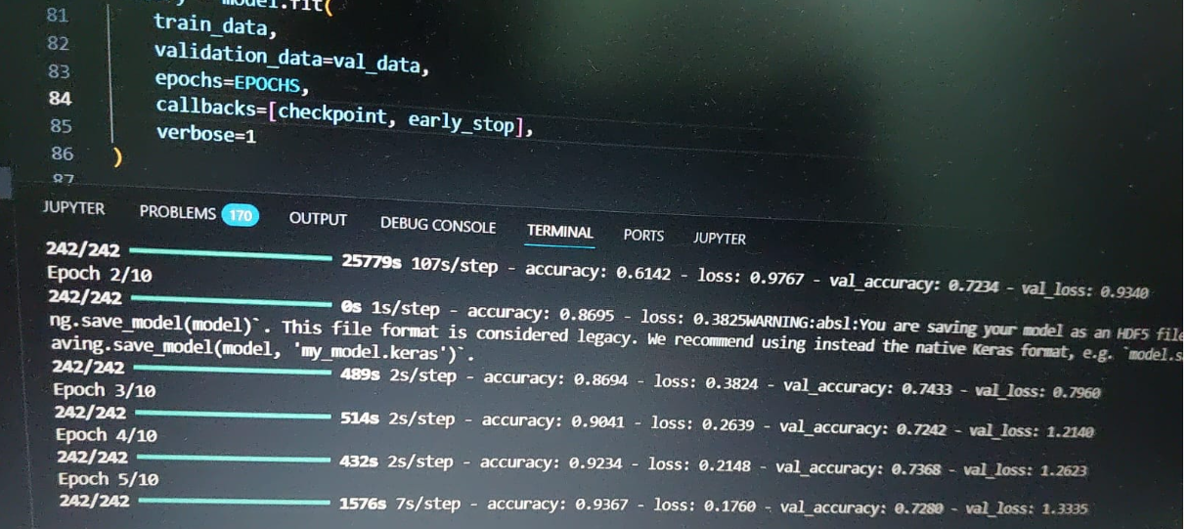

Accuracy score

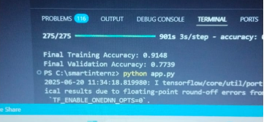

Validation Folder Structure

